3. Project Requirements & Goals ......................................................... 3
3.1 Core Functional Requirements ................................................. 3
- 3.1.1 User/Customer Requirements (Room Search, Booking, Payment)
- 3.1.2 Receptionist Requirements (Check-in/out, Walk-ins)
- 3.1.3 Administrator Requirements (Inventory, Pricing, Staff Management)
3.2 Key Quality Attributes (Non-functional Requirements) ........... 4
- Performance (Latency < 500ms)
- Security (JWT, RBAC, Data Protection)
- Reliability (Availability, Fault Tolerance)
- Maintainability (Layered Architecture)
3.3 Proposed Model of ASR (Architecturally Significant Requirements) ... 5
- ASR-1: Scalability (Microservices)
- ASR-2: Security (Role-Based Access Control)
- ASR-3: Modifiability (Strict Layered Pattern)
- ASR-4: Data Consistency (Transactional Integrity)
3.4 Use Case Modeling ................................................................. 6
- Use Case Diagram (UML)
- Detailed Flows: Make Reservation, Check-in, Check-out
4. Architectural Design & Implementation .......................................... 8
4.1 Architectural Pattern .............................................................. 8
- 4.1.1 Layered Architecture (Phase 1: Monolith)
- 4.1.2 Microservices Architecture (Phase 2: Scalability)
- 4.1.3 Event-Driven Architecture (RabbitMQ & Async Communication)
4.2 Technical Stack and Data Model ............................................. 10
- Backend: Python 3.9, Flask
- Database: MySQL 8.0 (ER Diagram)
- Containerization: Docker, Docker Compose
- Component Diagrams (C4 Level 1, 2, 3)
4.3 Interface Specifications ........................................................ 15
- 4.3.1 External API Interfaces (RESTful Endpoints)
- 4.3.2 Internal Service Interfaces (Controller-Service Contracts)
- 4.3.3 Database Interfaces (Repository Pattern)
- 4.3.4 Data Models & JSON Schemas
4.4 Implementation: Server-Side Logic (Python/Flask) ................... 20
- Service Layer Implementation
- Repository Layer Implementation
- Security Middleware (JWT Auth, RBAC)
- Event Producers & Consumers (RabbitMQ)
4.5 Implementation: Client-Side Logic (Web Interface) ................... 25
- User Interface Workflows
- API Integration (Fetch/Axios)
- Dynamic Status Updates
4.6 Architecture Decision Records (ADRs) .................................... 28
- ADR-001: Strict 4-Layer Architecture
- ADR-002: Framework Selection (Flask vs Django)
- ADR-003: Repository Pattern for Data Access
- ADR-004: JWT for Stateless Authentication
- ADR-005: Microservices Decomposition
5. Testing & Verification ..................................................................... 32
5.1 Verification Strategy .............................................................. 32
- Unit Testing & Integration Testing
- Performance/Load Testing results
5.2 Verification Proof: Traceability Matrix ................................... 33
- Mapping Requirements to Implementation
- Coverage Report (94.6% Implemented)
- Real-time functionality proofs
6. Conclusion & Reflection .................................................................. 36
6.1 Lessons Learned .................................................................... 36
6.2 Future Improvements .............................................................. 37

3. Project Requirements & Goals
3.1 Core Functional Requirements
3.1.1 User/Customer Requirements (Room Search, Booking, Payment)
These requirements define the specific behaviors and functions the system must provide.

ID | Requirement Name | Description | Priority
FR-01 | Room Search & Booking | The User must be able to search for rooms by date, type, and number of people, and complete the reservation online. | High
FR-02 | User Authentication | The User must be able to register and log in securely, including password recovery. | High
FR-03 | Booking Management | The User must be able to view, modify, or cancel their reservations. The system must store a full booking history. | High
FR-04 | Online Payment | The User must be able to make secure online payments for reservations and additional services (spa, dining). | High
FR-05 | Service Requests | The User must be able to request additional services (early check-in, late check-out, room service) during their stay. | Medium
FR-16 | Pricing & Discount Calculation | The system must automatically calculate the total booking price based on room rate, length of stay, and applied discounts or coupons. | High
FR-17 | Booking Status Tracking | The system must allow users to view the current status of their bookings (e.g., Pending, Confirmed, Checked-in, Checked-out, Cancelled). | High
FR-18 | Digital Wallet Usage | The User must be able to pay for bookings and services using an internal digital wallet balance. | Medium
FR-19 | Coupon Application | The User must be able to apply valid promotional coupons during the booking process. | Medium

3.1.2 Receptionist Requirements (Check-in/out, Walk-ins)
ID | Requirement Name | Description | Priority
FR-06 | Check-in/Check-out Processing | The Receptionist must be able to process guest check-in and check-out, including verifying bookings and issuing keys. | High
FR-07 | Walk-in Booking | The Receptionist must be able to create new bookings for guests arriving directly at the counter (walk-in guests). | High
FR-08 | Room Assignment | The Receptionist must be able to assign specific rooms to bookings based on room status and guest preferences. | High
FR-09 | Guest Profile Management | The Receptionist must be able to view and update guest profile information. | Medium
FR-10 | Payment Collection | The Receptionist must be able to collect payments at the counter (cash/card) and issue invoices. | High
FR-20 | Room Status Management | The Receptionist must be able to view and update room status (Available, Occupied, Under Maintenance) during daily operations. | High
3.1.3 Administrator Requirements (Inventory, Pricing, Staff Management)
ID | Requirement Name | Description | Priority
FR-11 | Room Inventory Management | The Administrator must be able to perform full CRUD operations on the room catalog (add new rooms, update details, price) and manage room status (e.g., Under Maintenance). | High
FR-12 | Staff Management | The Administrator must be able to create and manage staff accounts, including assigning roles (e.g., Receptionist, Housekeeper) and resetting passwords. | High
FR-13 | Service Management | The Administrator must be able to update the catalog of hotel services (Spa, Dining menu) | Medium
FR-14 | Analytics & Reporting | The Administrator must have access to detailed reports on occupancy rates, revenue, and service performance. | Medium
FR-15 | Role-Based Access Control (RBAC) | System enforces permissions: User accesses own data only; Receptionist handles operations; Admin manages system resources. | High
FR-21 | Transaction & Activity History | The Administrator must be able to view historical records of bookings, payments, service requests, and system activities. | Low

3.2 Key Quality Attributes (Non-functional Requirements)
Non-functional requirements define the quality attributes that the system must satisfy to ensure reliability, security, performance, and long-term maintainability.
These requirements are specified at two complementary levels:
- Level 1 – Quality Attribute Goals (Stakeholder View): what quality the system must achieve
- Level 2 – Quality Attribute Elaboration (Architectural View): how these goals are realized and measured
ID | Attribute | Description | Impact
NFR-01 | Performance (Latency) | Room search responds within ≤ 2.0 seconds under normal operational load. | High
NFR-02 | Security (Data Integrity) | All user data is transmitted via HTTPS; payment card data is not stored and is processed by a PCI-aware payment gateway. | Critical
NFR-03 | Reliability (Availability) | Online booking service uptime target is ≥ 99.9% during business operation. | Critical
NFR-04 | Data Consistency | Booking, payment, and service operations must be atomic, preventing partial or inconsistent records. | Critical
NFR-05 | Security (Authentication) | User passwords are stored as salted hashes; authentication tokens or sessions expire after a defined time. | High
NFR-06 | Security (Injection Protection) | The system prevents SQL injection attacks using parameterized queries or ORM mechanisms. | High
NFR-07 | Usability | The main booking flow can be completed in ≤ 5 steps, with clear and actionable error messages. | Medium
NFR-08 | Maintainability | Business logic changes must not require rewriting the user interface layer. | High
NFR-09 | Auditability | Critical system actions (login attempts, admin operations, payment state changes) are logged. | Medium
NFR-10 | Scalability | The system can scale from 100 to 1,000 concurrent users by adding backend instances (future deployment). | High
NFR-11 | Compatibility | The system works correctly on modern browsers (latest Chrome, Firefox, Edge, Safari). | Medium
NFR-12 | Backup & Recovery | Daily database backups are performed; recovery procedures are documented with RPO ≤ 24 hours. | High

2 Quality Attribute Elaboration (Architectural View)
This section elaborates the above quality attributes into measurable metrics and architectural tactics, demonstrating how the system achieves the stated quality goals.

NFR-01 Performance (Latency)
- 95th percentile API response time < 500 ms for room search requests
- Web page load time < 3 seconds
- Typical indexed database queries complete within 200 ms
- Uploaded room images are optimized to < 2 MB per file

NFR-02, NFR-05, NFR-06 Security
- All communication uses HTTPS in production environments
- Passwords are hashed with salt before storage
- JWT-based authentication is used with a defined expiration time
- Role-Based Access Control (RBAC) is enforced for all API endpoints
- SQL injection is prevented through parameterized queries or ORM
- CORS policies restrict unauthorized cross-origin access
- User inputs are validated and sanitized

NFR-03 Reliability & NFR-04 Data Consistency
- Database transactions use appropriate isolation levels to ensure consistency
- Booking–payment–service workflows are handled atomically
- Comprehensive error handling prevents partial data persistence
- Graceful degradation is applied when a dependent service fails

NFR-07 Usability
- User interface is responsive on both desktop and mobile devices
- Booking flow is designed to be completed in ≤ 5 user interactions
- Error messages are clear, human-readable, and guide corrective action
- The system supports multiple languages (Vietnamese and English)

NFR-08 Maintainability
- Layered architecture with clear separation of concerns
- Business logic is isolated from presentation logic
- Code follows consistent naming conventions and style guidelines
- Centralized logging supports easier debugging and maintenance
- API documentation is maintained and kept up to date

NFR-09 Auditability
- System logs record authentication attempts, administrative CRUD actions, and payment status changes
- Logs support troubleshooting, security auditing, and dispute resolution

NFR-10 Scalability
- Backend services are designed to be stateless
- Architecture supports horizontal scaling via multiple instances
- Load balancing can be introduced without major refactoring
- Database design supports future partitioning or tenant-based separation

NFR-11 Compatibility
- Frontend is tested against modern, standards-compliant browsers
- No reliance on deprecated browser-specific features

NFR-12 Backup & Recovery
- Automated daily database backups
- Recovery procedures are documented and tested
- Recovery Point Objective (RPO) is ≤ 24 hours for project scope

3.3 Proposed Model of ASR (Architecturally Significant Requirements)
These are the non-functional requirements that have the most profound influence on the system's architecture, driving the selection of patterns.

ASR ID | Quality Attribute | Requirement Statement | Architectural Rationale
ASR-1 | Scalability | The architecture must support a sudden increase in traffic from 100 to 1,000 concurrent users during peak holiday seasons. | This drives the Python backend towards a stateless design, allowing for horizontal scaling and effective load balancing in future deployment stages. Note: Currently, the system is implemented as a monolithic Layered Architecture. The transition to Microservices Architecture (as designed in Lab 4) will address this scalability requirement more effectively by allowing independent scaling of high-demand services (e.g., Room Search) without scaling the entire application.
ASR-2 | Security | All access to administration functionalities (FR-11, FR-12, FR-13, FR-14) must be restricted to authenticated administrators via secure session/token validation. | This necessitates a dedicated Security Middleware/Component located in the Business Logic layer to enforce access control before requests reach the data. This ensures all administrative operations (room management, staff management, services, reporting) are fully protected regardless of request origin (UI or API).
ASR-3 | Modifiability | Updates to the Presentation Layer must not require changes to the Business Logic or Persistence layers. | Enforces the principle of Separation of Concerns. The architecture must strictly separate the Presentation Layer from the Business Layer, ensuring UI changes do not break core functionality.
ASR-4 | Data Consistency  / Reliability | Prevent double-booking and ensure booking-payment updates are transactional. | Drives transaction boundaries, v  alidation at service layer,  and DB constraints to preserve integrity.
3.4 Use Case Modeling

I Modeling Artifact: UML Use Case Diagram
The UML Use Case Diagram below models the functional scope of the Hotel Management System.
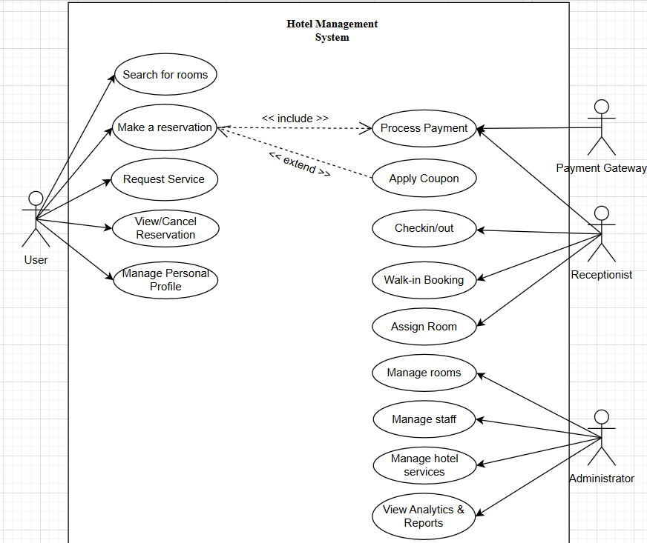
- Actors: The system interacts with four primary actors: User, Admin (Administrator), Receptionist and Payment Gateway.
- System Boundary: The box delineates the scope of the Hotel Management System.
- User Interactions: Interacts with the system to search for rooms, make reservations, and manage their personal profile.
- Administrator Interactions: Responsible for managing hotel resources (rooms, staff, services, view analytics and reports).
- Payment Gateway Interactions: Validates credit card information and processes financial transactions when prompted by the system during the reservation process. It returns the transaction status (Success/Failure) to the Hotel Management System.

Detailed Flows: Make Reservation, Check-in, Check-out

UC-01: Make a Reservation (Table Format)

Main Flow
Step | Actor | Action / System Response | Output
1 | Customer | Enter check-in/out dates and guests | Search criteria
2 | System | Display available rooms | Room list
3 | Customer | Select room/type | Selected room
4 | System | Show booking summary (nights, price) | Booking summary
5 | Customer | Confirm booking info | Confirmation
6 | Customer | Choose payment method and pay | Payment request
7 | System | Process payment via Payment Service/Gateway | Payment result
8 | System | Create booking with status CONFIRMED | Booking record
9 | System | Reserve room for selected period | Room status updated
10 | System | Send confirmation email / publish event | Notification queued/sent

Alternative Flows
Alt ID | Condition | System Behavior | Result
A1 | No rooms available | Show “No rooms available”, suggest changing dates/type | Booking not created
A2 | Payment fails | Show payment error, allow retry/other method | No confirmed booking
Postcondition: Booking stored, payment recorded, notification sent/queued.

UC-02: Check-In Guest (Table Format)

Main Flow
Step | Actor | Action / System Response | Output
1 | Receptionist | Search booking by name/booking ID | Booking found
2 | System | Display booking details | Booking info
3 | Receptionist | Verify guest identity (ID/CCCD) | Verification
4 | Receptionist | Assign room (if not assigned) | Room allocation
5 | Receptionist | Confirm check-in | Check-in request
6 | System | Update booking status → CHECKED_IN | Booking updated
7 | System | Update room status → OCCUPIED | Room updated
8 | System | Generate/log key card info | Key issued
9 | Receptionist | Hand over key to guest | Completed

Alternative Flows
Alt ID | Condition | System Behavior | Result
B1 | Booking not found | Redirect to Walk-in booking flow | New booking created
B2 | Early check-in | Warn + optional fee policy | Fee applied if enabled
Postcondition: Guest checked in; room is occupied.

UC-03: Check-Out Guest (Table Format)

Main Flow
Step | Actor | Action / System Response | Output
1 | Receptionist | Retrieve booking by room number | Booking located
2 | System | Calculate final bill (room + services) | Total amount
3 | Receptionist | Inform guest of total payment | Payment due
4 | Guest | Pay remaining balance | Payment completed
5 | Receptionist | Confirm check-out | Checkout request
6 | System | Update booking status → CHECKED_OUT | Booking closed
7 | System | Set room status → DIRTY | Cleaning required
8 | System | Generate invoice + send thank-you email/event | Invoice sent/queued

Alternative Flows
Alt ID | Condition | System Behavior | Result
C1 | Late check-out | Add late fee automatically | Updated invoice
C2 | Damage reported | Add compensation fee | Updated invoice
Postcondition: Guest checked out; room ready for housekeeping.
4. Architectural Design & Implementation
4.1 Architectural Pattern
- 4.1.1 Layered Architecture (Phase 1: Monolith)
- 4.1.2 Microservices Architecture (Phase 2: Scalability)
- 4.1.3 Event-Driven Architecture (RabbitMQ & Async Communication)
4.2 Technical Stack and Data Model ............................................. 10
- Backend: Python 3.9, Flask
- Database: MySQL 8.0 (ER Diagram)
- Containerization: Docker, Docker Compose
- Component Diagrams (C4 Level 1, 2, 3)
4.3 Interface Specifications ........................................................ 15
- 4.3.1 External API Interfaces (RESTful Endpoints)
- 4.3.2 Internal Service Interfaces (Controller-Service Contracts)
- 4.3.3 Database Interfaces (Repository Pattern)
- 4.3.4 Data Models & JSON Schemas
4.4 Implementation: Server-Side Logic (Python/Flask) ................... 20
- Service Layer Implementation
- Repository Layer Implementation
- Security Middleware (JWT Auth, RBAC)
- Event Producers & Consumers (RabbitMQ)
4.5 Implementation: Client-Side Logic (Web Interface) ................... 25
- User Interface Workflows
- API Integration (Fetch/Axios)
- Dynamic Status Updates
4.6 Architecture Decision Records (ADRs) .................................... 28
- ADR-001: Strict 4-Layer Architecture
- ADR-002: Framework Selection (Flask vs Django)
- ADR-003: Repository Pattern for Data Access
- ADR-004: JWT for Stateless Authentication
- ADR-005: Microservices Decomposition
5. Testing & Verification ..................................................................... 32
5.1 Verification Strategy .............................................................. 32
- Unit Testing & Integration Testing
- Performance/Load Testing results
5.2 Verification Proof: Traceability Matrix ................................... 33
- Mapping Requirements to Implementation
- Coverage Report (94.6% Implemented)
- Real-time functionality proofs
6. Conclusion & Reflection .................................................................. 36
6.1 Lessons Learned .................................................................... 36
6.2 Future Improvements .............................................................. 37

3. LAB 1: REQUIREMENTS ELICITATION & MODELING .......... 12
- 3.1 Stakeholder Identification
- 3.2 Functional Requirements
- 3.3 Non-Functional Requirements
- 3.4 Architecturally Significant Requirements (ASRs)
- 3.5 Use Case Diagram
- 3.6 Requirements Traceability Matrix
4. LAB 2: LAYERED ARCHITECTURE DESIGN ................ 24
- 4.1 Layer Definitions & Responsibilities
- 4.2 Component Identification
- 4.3 Interface Specifications
- 4.4 Component Diagram
- 4.5 Data Flow Analysis
- 4.6 Architecture Decision Records (ADRs)
- 4.7 Architectural Design Decisions
- 4.8 Traceability to Requirements
5. LAB 3: LAYERED ARCHITECTURE IMPLEMENTATION ......... 38
- 5.1 Implementation Architecture
- 5.2 Database Design
- 5.3 API Endpoints
- 5.4 Sequence Diagrams
- 5.5 Testing Results
6. LAB 4: MICROSERVICES DECOMPOSITION ................ 52
- 6.1 Service Decomposition Strategy
- 6.2 Service Contracts (API Design)
- 6.3 C4 Model Diagrams
- 6.4 Communication Strategy
- 6.5 Database-per-Service Pattern
8. LAB 6: API GATEWAY PATTERN ....................... 72
- 8.1 Gateway Architecture
- 8.2 Implementation
- 8.3 Security & Cross-Cutting Concerns
- 8.4 Testing Results

3. LAB 1: REQUIREMENTS ELICITATION & MODELING .
3.1 Stakeholder Identification
I Stakeholder Identification & Analysis
1. Primary Stakeholders
Stakeholder | Role | Goals | Pain Points | System Interaction
Web Customer (Guest) | Online hotel guest | - Find suitable rooms- Book rooms quickly- Pay securely | - Long booking process- Unclear pricing- Lack of real-time room availability | - Search rooms- Make bookings- Perform online payments- View and manage reservations
Receptionist | Front desk staff | - Fast check-in/check-out- Manage walk-in guests- Handle guest requests efficiently | - Manual data entry- No real-time room status- Difficult payment tracking | - Confirm bookings- Assign rooms- Process check-in/check-out- Collect payments
Administrator (Hotel Manager) | Hotel system administrator | - Monitor hotel operations- Analyze business performance- Manage system resources | - No centralized dashboard- Manual reporting- Difficult staff management | - Manage rooms, services, and staff- Configure system settings- View analytical reports
Hotel Owner / Management Board | Business owner | - Maximize revenue- Monitor hotel performance | - Lack of aggregated business data- Delayed decision-making | - View high-level dashboards- Review business KPIs
Accounting / Finance Staff | Financial controller | - Reconcile payments- Ensure financial accuracy | - Fragmented transaction data- Risk of reporting errors | - Access transaction history- Generate financi
2. Secondary Stakeholders
Stakeholder | Interest | Influence | Requirements
Hotel Owner | Return on Investment (ROI), business growth | High | Cost-effective solution, measurable revenue improvement, management reports
Accountant | Financial accuracy, auditing and compliance | Medium | Detailed transaction logs, financial statements, refund and adjustment tracking
Housekeeping Staff | Room cleanliness and availability status | Medium | Real-time room status updates (clean, dirty, under maintenance)
IT Support | System stability and maintainability | Medium | Easy deployment, clear technical documentation, minimal system downtime

3.2 Functional Requirements (FRs)
3.2.1 User/Customer Requirements
These requirements define the specific behaviors and functions the system must provide.
- User Functional Requirements

ID | Requirement Name | Description | Priority
FR-01 | Room Search & Booking | The User must be able to search for rooms by date, type, and number of people, and complete the reservation online. | High
FR-02 | User Authentication | The User must be able to register and log in securely, including password recovery. | High
FR-03 | Booking Management | The User must be able to view, modify, or cancel their reservations. The system must store a full booking history. | High
FR-04 | Online Payment | The User must be able to make secure online payments for reservations and additional services (spa, dining). | High
FR-05 | Service Requests | The User must be able to request additional services (early check-in, late check-out, room service) during their stay. | Medium
FR-16 | Pricing & Discount Calculation | The system must automatically calculate the total booking price based on room rate, length of stay, and applied discounts or coupons. | High
FR-17 | Booking Status Tracking | The system must allow users to view the current status of their bookings (e.g., Pending, Confirmed, Checked-in, Checked-out, Cancelled). | High
FR-18 | Digital Wallet Usage | The User must be able to pay for bookings and services using an internal digital wallet balance. | Medium
FR-19 | Coupon Application | The User must be able to apply valid promotional coupons during the booking process. | Medium
- Receptionist Functional Requirements

ID | Requirement Name | Description | Priority
FR-06 | Check-in/Check-out Processing | The Receptionist must be able to process guest check-in and check-out, including verifying bookings and issuing keys. | High
FR-07 | Walk-in Booking | The Receptionist must be able to create new bookings for guests arriving directly at the counter (walk-in guests). | High
FR-08 | Room Assignment | The Receptionist must be able to assign specific rooms to bookings based on room status and guest preferences. | High
FR-09 | Guest Profile Management | The Receptionist must be able to view and update guest profile information. | Medium
FR-10 | Payment Collection | The Receptionist must be able to collect payments at the counter (cash/card) and issue invoices. | High
FR-20 | Room Status Management | The Receptionist must be able to view and update room status (Available, Occupied, Under Maintenance) during daily operations. | High
- Hotel Manager Functional Requirements (Administrator)

ID | Requirement Name | Description | Priority
FR-11 | Room Inventory Management | The Administrator must be able to perform full CRUD operations on the room catalog (add new rooms, update details, price) and manage room status (e.g., Under Maintenance). | High
FR-12 | Staff Management | The Administrator must be able to create and manage staff accounts, including assigning roles (e.g., Receptionist, Housekeeper) and resetting passwords. | High
FR-13 | Service Management | The Administrator must be able to update the catalog of hotel services (Spa, Dining menu) | Medium
FR-14 | Analytics & Reporting | The Administrator must have access to detailed reports on occupancy rates, revenue, and service performance. | Medium
FR-15 | Role-Based Access Control (RBAC) | System enforces permissions: User accesses own data only; Receptionist handles operations; Admin manages system resources. | High
FR-21 | Transaction & Activity History | The Administrator must be able to view historical records of bookings, payments, service requests, and system activities. | Low
3.3 Non-Functional Requirements
Non-functional requirements define the quality attributes that the system must satisfy to ensure reliability, security, performance, and long-term maintainability.
These requirements are specified at two complementary levels:
- Level 1 – Quality Attribute Goals (Stakeholder View): what quality the system must achieve
- Level 2 – Quality Attribute Elaboration (Architectural View): how these goals are realized and measured
1 Quality Attribute Summary (Stakeholder View)
ID | Attribute | Description | Impact
NFR-01 | Performance (Latency) | Room search responds within ≤ 2.0 seconds under normal operational load. | High
NFR-02 | Security (Data Integrity) | All user data is transmitted via HTTPS; payment card data is not stored and is processed by a PCI-aware payment gateway. | Critical
NFR-03 | Reliability (Availability) | Online booking service uptime target is ≥ 99.9% during business operation. | Critical
NFR-04 | Data Consistency | Booking, payment, and service operations must be atomic, preventing partial or inconsistent records. | Critical
NFR-05 | Security (Authentication) | User passwords are stored as salted hashes; authentication tokens or sessions expire after a defined time. | High
NFR-06 | Security (Injection Protection) | The system prevents SQL injection attacks using parameterized queries or ORM mechanisms. | High
NFR-07 | Usability | The main booking flow can be completed in ≤ 5 steps, with clear and actionable error messages. | Medium
NFR-08 | Maintainability | Business logic changes must not require rewriting the user interface layer. | High
NFR-09 | Auditability | Critical system actions (login attempts, admin operations, payment state changes) are logged. | Medium
NFR-10 | Scalability | The system can scale from 100 to 1,000 concurrent users by adding backend instances (future deployment). | High
NFR-11 | Compatibility | The system works correctly on modern browsers (latest Chrome, Firefox, Edge, Safari). | Medium
NFR-12 | Backup & Recovery | Daily database backups are performed; recovery procedures are documented with RPO ≤ 24 hours. | High

2 Quality Attribute Elaboration (Architectural View)
This section elaborates the above quality attributes into measurable metrics and architectural tactics, demonstrating how the system achieves the stated quality goals.

NFR-01 Performance (Latency)
- 95th percentile API response time < 500 ms for room search requests
- Web page load time < 3 seconds
- Typical indexed database queries complete within 200 ms
- Uploaded room images are optimized to < 2 MB per file

NFR-02, NFR-05, NFR-06 Security
- All communication uses HTTPS in production environments
- Passwords are hashed with salt before storage
- JWT-based authentication is used with a defined expiration time
- Role-Based Access Control (RBAC) is enforced for all API endpoints
- SQL injection is prevented through parameterized queries or ORM
- CORS policies restrict unauthorized cross-origin access
- User inputs are validated and sanitized

NFR-03 Reliability & NFR-04 Data Consistency
- Database transactions use appropriate isolation levels to ensure consistency
- Booking–payment–service workflows are handled atomically
- Comprehensive error handling prevents partial data persistence
- Graceful degradation is applied when a dependent service fails

NFR-07 Usability
- User interface is responsive on both desktop and mobile devices
- Booking flow is designed to be completed in ≤ 5 user interactions
- Error messages are clear, human-readable, and guide corrective action
- The system supports multiple languages (Vietnamese and English)

NFR-08 Maintainability
- Layered architecture with clear separation of concerns
- Business logic is isolated from presentation logic
- Code follows consistent naming conventions and style guidelines
- Centralized logging supports easier debugging and maintenance
- API documentation is maintained and kept up to date

NFR-09 Auditability
- System logs record authentication attempts, administrative CRUD actions, and payment status changes
- Logs support troubleshooting, security auditing, and dispute resolution

NFR-10 Scalability
- Backend services are designed to be stateless
- Architecture supports horizontal scaling via multiple instances
- Load balancing can be introduced without major refactoring
- Database design supports future partitioning or tenant-based separation

NFR-11 Compatibility
- Frontend is tested against modern, standards-compliant browsers
- No reliance on deprecated browser-specific features

NFR-12 Backup & Recovery
- Automated daily database backups
- Recovery procedures are documented and tested
- Recovery Point Objective (RPO) is ≤ 24 hours for project scope
3.4 Architecturally Significant Requirements (ASRs)
These are the non-functional requirements that have the most profound influence on the system's architecture, driving the selection of patterns.

ASR ID | Quality Attribute | Requirement Statement | Architectural Rationale
ASR-1 | Scalability | The architecture must support a sudden increase in traffic from 100 to 1,000 concurrent users during peak holiday seasons. | This drives the Python backend towards a stateless design, allowing for horizontal scaling and effective load balancing in future deployment stages. Note: Currently, the system is implemented as a monolithic Layered Architecture. The transition to Microservices Architecture (as designed in Lab 4) will address this scalability requirement more effectively by allowing independent scaling of high-demand services (e.g., Room Search) without scaling the entire application.
ASR-2 | Security | All access to administration functionalities (FR-11, FR-12, FR-13, FR-14) must be restricted to authenticated administrators via secure session/token validation. | This necessitates a dedicated Security Middleware/Component located in the Business Logic layer to enforce access control before requests reach the data. This ensures all administrative operations (room management, staff management, services, reporting) are fully protected regardless of request origin (UI or API).
ASR-3 | Modifiability | Updates to the Presentation Layer must not require changes to the Business Logic or Persistence layers. | Enforces the principle of Separation of Concerns. The architecture must strictly separate the Presentation Layer from the Business Layer, ensuring UI changes do not break core functionality.
ASR-4 | Data Consistency  / Reliability | Prevent double-booking and ensure booking-payment updates are transactional. | Drives transaction boundaries, v  alidation at service layer,  and DB constraints to preserve integrity.
3.5 Use Case Diagram

I Modeling Artifact: UML Use Case Diagram
The UML Use Case Diagram below models the functional scope of the Hotel Management System.

- Actors: The system interacts with four primary actors: User, Admin (Administrator), Receptionist and Payment Gateway.
- System Boundary: The box delineates the scope of the Hotel Management System.
- User Interactions: Interacts with the system to search for rooms, make reservations, and manage their personal profile.
- Administrator Interactions: Responsible for managing hotel resources (rooms, staff, services, view analytics and reports).
- Payment Gateway Interactions: Validates credit card information and processes financial transactions when prompted by the system during the reservation process. It returns the transaction status (Success/Failure) to the Hotel Management System.

Receptionist Interactions: Handles the daily operations at the front desk, including checking guests in and out, verifying bookings, and receiving direct payments if applicable.
3.6 Assumptions & Constraints

I Assumptions
ID | Assumption | Impact if Invalid | Mitigation Strategy
A-01 | The hotel has a stable internet connection (≥ 10 Mbps). | System becomes unusable during connectivity loss. | Provide limited offline support for critical operations such as check-in/check-out.
A-02 | Users access the system using modern browsers (latest 2 versions of Chrome, Firefox, Safari). | UI rendering issues and degraded user experience. | Display browser compatibility warnings and recommend supported browsers.
A-03 | The payment gateway (e.g., Stripe, PayPal) maintains ≥ 99.9% uptime. | Payment processing failures during gateway outages. | Support multiple payment gateways and allow fallback to cash/manual payments.
A-04 | Peak concurrent users do not exceed 100. | Performance degradation under higher load. | Monitor traffic continuously and enable horizontal scaling when thresholds are exceeded.
A-05 | Database size remains below 10 GB during the first year. | Storage and performance bottlenecks. | Enable automated backups and archive historical booking data annually.

II Constraints
ID | Constraint | Type | Justification
C-01 | Development budget ≤ 5,000 USD. | Financial | Target customers are small hotels; open-source technologies are required to minimize cost.
C-02 | Must use Python and Flask. | Technical | Team expertise in Python enables faster and safer development.
C-03 | Deployment on a single server (2 CPU cores, 4 GB RAM). | Technical | Infrastructure cost limitation; cloud migration planned if traffic grows.
C-04 | Go-live within 3 months. | Time | Hotel owner deadline; requires iterative and agile development.
C-05 | Compliance with Vietnam Personal Data Protection Decree No. 13/2023. | Legal | Mandatory data privacy regulation; sensitive data must be encrypted and user consent obtained.
C-06 | No integration with external OTAs (Booking.com, Agoda) in version 1.0. | Scope | Focus on core hotel operations first; OTA integration planned for Phase 2.

III Success Criteria
The project is considered successful when both functional and business objectives are met.

3.1 Functional Success Criteria
ID | Criterion | Measurement Method | Target
SC-01 | All functional requirements implemented. | Feature checklist | 100% (21/21)
SC-02 | All non-functional requirements satisfied. | Performance testing, code review | 100% (12/12)
SC-03 | No critical defects after 1 month in production. | Bug tracking system | 0 critical, < 5 minor issues
SC-04 | User Acceptance Testing (UAT) passed. | Sign-off from hotel manager | Approved

3.2 Business Success Criteria
ID | Criterion | Measurement Method | Target
SC-05 | Booking time reduction. | Time measurement | From 30 min → 5 min (≈ 83% reduction)
SC-06 | Check-in time reduction. | Time measurement | From 15 min → 5 min (≈ 67% reduction)
SC-07 | Online booking adoption rate. | System analytics | ≥ 50% of total bookings
SC-08 | Customer satisfaction score. | Survey (1–5 scale) | Average ≥ 4.0
SC-09 | System availability. | Monitoring logs | ≥ 99.5% during first 3 months

IV Product Vision & Roadmap

1 Product Vision Statement
Demacia Hotel Management System aims to become a leading affordable hotel management platform for small and medium-sized hotels in Vietnam, enabling them to compete with larger hotel chains through automation, modern technology, and data-driven decision making.

2 Product Roadmap

Phase 1: Core MVP (Months 1–3) — Current Scope
- User authentication & RBAC
- Room catalog and availability search
- Online booking and payment
- Check-in / check-out workflows
- Basic reporting (revenue, occupancy)

Phase 2: Mobile & Integrations (Months 4–6)
- Mobile application (iOS & Android)
- Integration with Booking.com and Agoda
- Advanced email marketing
- Additional payment gateways (MoMo, ZaloPay)

Phase 3: Advanced Features (Months 7–12)
- AI-powered dynamic pricing
- Advanced analytics and forecasting
- Multi-property hotel management
- Multi-language support (EN, VI, CN, KR)

Phase 4: Enterprise Features (Year 2+)
- IoT integration (smart locks, air conditioning control)
- Customer segmentation and loyalty programs
- Channel management for distribution
- Cloud-native deployment (AWS / GCP)

3.6 Requirements Traceability Matrix

Forward Traceability: Requirements → Design → Implementation → Testing
Requirement | Use Case | Component (Lab 2) | Implementation (Lab 3) | Test Case
FR-01: Room Search | UC-01 | RoomController → RoomService → RoomRepository | GET /api/rooms/search | TC-001
FR-02: Authentication | UC-01 (Precondition) | UserController, Auth Middleware | POST /api/users/login | TC-002
FR-06: Check-In | UC-02 | CheckInController → CheckInService | POST /api/checkins | TC-015
ASR-2: RBAC | UC-12 (Admin only) | @require_admin decorator | Access control validation | TC-030
NFR-01: Performance | All use cases | DB indexing, query optimization | Load test (100 users) | TC-PERF

4. LAB 2: LAYERED ARCHITECTURE DESIGN
4.1 Layer Definitions & Responsibilities
I. Defining Layers and Responsibilities
In this section, we define the four architectural layers for the Hotel Management System, strictly adhering to the Layered Architecture Pattern where a layer can only interact with the layer directly below it.

1.1. Description of Layers
Layer | Purpose/Responsibility | Output/Artifact
1. Presentation Layer (UI) | Handles HTTP requests, user authentication, session management, and renders the user interface. It ensures the separation of the frontend (HTML/CSS) from the backend logic. | Controllers (e.g., RoomController, BookingController), Templates (HTML views), Static Files (CSS/JS).
2. Business Logic Layer (Service) | Contains the core business rules, validation logic, and transaction management. It orchestrates data access and handles integrations with external systems (like the Payment Gateway). | Services (e.g., BookingService, PaymentService, RoomService).
3. Persistence Layer (Data Access) | Responsible for mapping business objects to database entities and executing CRUD (Create, Read, Update, Delete) operations. It abstracts the database queries from the business logic. | Repositories/DAOs (e.g., BookingRepository, RoomRepository).
4. Data Layer | The physical database storage system where all application data is persisted. | Database Schema (MySQL/PostgreSQL), Tables (Guests, Rooms, Bookings).

Design Decisions:
- Strict layering (upper layers depend on lower only)
- Repository pattern for data access abstraction
- Service layer for business logic centralization
- Flask for REST API presentatio

1.2. Data Flow
Scenario: Check Room Availability Flow
- Client Request: The user (Guest/Staff Portal) sends an HTTP GET request to the endpoint: /rooms/availability?checkin=2025-12-20&roomType=DELUXE.
- Layer 1 (Presentation): The RoomController receives the request, performs user session authentication, and validates the date format. It then invokes Layer 2.
- Layer 2 (Business Logic): The RoomService executes the findAvailableRooms(checkin, type) function. Here, the system applies business rules, such as checking for minimum stay duration requirements.
- Layer 3 (Persistence): The RoomRepository (shown within the Business Logic flow in the diagram but effectively handling data access) receives the command and constructs a complex SQL query: SELECT r.* FROM rooms r LEFT JOIN reservations res WHERE ... AND roomType = ?.
- Layer 4 (Data): The Database (PostgreSQL) executes the JOIN command to filter for rooms that are not booked during the specified period and returns the raw data.
- Return Path:
  - The RoomRepository maps the raw data from the Database into Room Objects.
  - The RoomService calculates the final pricing (Pricing Logic).
  - The RoomController returns the "Available rooms response" (JSON/HTML) to the Client.
4.2 Component Identification

II. Component Identification (Product Catalog)
This section breaks down the critical "Make a Reservation" feature into concrete software components residing in the top three layers.

3.1. Identify Components
Layer 1: Presentation Layer
- Component Name: BookingController
- Responsibility: Receives the booking request (POST /book), validates input format (forms), and delegates processing to the BookingService.
Layer 2: Business Logic Layer
- Component Name: BookingService
- Responsibility: Coordinates the reservation process. It checks room availability via RoomService, processes financial transactions via PaymentService (interface with Payment Gateway), and calculates total costs.
- Component Name: PaymentService
- Responsibility: Encapsulates the logic for communicating with the external Payment Gateway (Actor), ensuring security and isolating third-party dependencies.
Layer 3: Persistence Layer
- Component Name: BookingRepository
- Responsibility: Translates the finalized booking object into a database insert command (INSERT INTO bookings...) to persist the reservation.

3.2. Define Interfaces
The following interfaces define the contracts between layers:
- Interface provided by Business Logic (for Presentation):
  - IBookingService.createReservation(bookingRequest: Dict) -> BookingResult
- Interface provided by Persistence (for Business Logic):
  - IBookingRepository.save(booking: BookingEntity) -> void
  - IBookingRepository.findById(bookingId: int) -> BookingEntity
4.3 Interface Specifications

4.3.1 Overview
This section specifies the interfaces between architectural components of the Demacia Hotel Management System.
The goal is to define clear and stable contracts for communication between layers and external systems, ensuring loose coupling, maintainability, and security.
Specifically, this section addresses:
- Clear interaction contracts between Presentation, Business Logic, Persistence, and Data layers
- Explicit request/response formats and error handling
- Security requirements for authentication and authorization
- Versioning strategy to support future evolution
Interfaces are categorized into:
- External REST APIs
- Internal Service Interfaces
- Repository (Database) Interfaces
- External System Interfaces

4.3.2 External API Interfaces (REST)

API-01: Create Booking
- Endpoint: POST /api/bookings
- Authentication: Required (JWT Bearer Token)
- Authorization: USER, RECEPTIONIST, ADMIN
Request Body (JSON):
{
"room_id": 101,
"check_in": "2024-12-20",
"check_out": "2024-12-25",
"payment_method": "CARD"
}
Success Response (201 Created):
{
"booking_id": 42,
"status": "CONFIRMED",
"total_price": 1500.00
}
Error Responses:
Status | Error Code | Description
400 | INVALID_INPUT | Invalid dates or missing fields
401 | INVALID_TOKEN | Missing or expired JWT
403 | FORBIDDEN | Insufficient permissions
404 | ROOM_NOT_FOUND | Room does not exist
409 | ROOM_UNAVAILABLE | Room already booked
500 | PAYMENT_ERROR | Payment gateway failure
Performance SLA:
- 95th percentile response time < 500 ms

4.3.3 Internal Service Interfaces

Interface: BookingController → BookingService
class IBookingService:
def create_booking(
self,
user_id: int,
room_id: int,
check_in: date,
check_out: date,
payment_method: str
) -> Tuple[dict, int]:
"""
Creates a booking after validating availability and processing payment.
Raises validation, availability, or payment exceptions if constraints fail.
"""
Responsibilities:
- Validate business rules
- Detect booking conflicts
- Calculate pricing
- Coordinate payment and booking creation

4.3.4 Data Contracts
Booking Request Contract:
- room_id: integer (>0)
- check_in, check_out: YYYY-MM-DD
- payment_method: CARD | WALLET | CASH
Booking Response Contract:
- booking_id, total_price, status, created_at
Input validation is enforced using schema-based validation to prevent invalid or malicious data.

4.3.5 Repository Interfaces

Interface: BookingService → BookingRepository
class IBookingRepository:
def create(self, booking_data: dict) -> dict
def find_conflicts(self, room_id: int, check_in: str, check_out: str) -> List[dict]
All SQL queries are isolated in the Persistence layer, ensuring:
- Protection against SQL injection
- Database technology independence
- Clear separation from business logic

4.3.6 External System Interfaces

Payment Gateway Interface
- Protocol: HTTPS REST
- Authentication: API Key
- Failure Handling:
  - Retry up to 3 times
  - Rollback booking on payment failure
  - Circuit breaker on repeated errors
This ensures that payment failures do not compromise data consistency.

4.3.7 Error Handling Strategy
The system defines a centralized exception hierarchy with standardized error codes and HTTP statuses.
Example:
- ValidationError → 400
- RoomUnavailableError → 409
- PaymentError → 500
All exceptions are handled by a global error handler, ensuring consistent API responses.

4.3.8 Interface Versioning Strategy
- Versioning Approach: URL-based (/api/v1/...)
- Backward-compatible changes are allowed within the same version
- Breaking changes require a new major version
This strategy ensures safe API evolution without disrupting existing clients.

4.3.9 Security Specifications
- JWT-based authentication
- Role-Based Access Control (RBAC)
- Authorization enforced at controller and service layers
Example:
- Only ADMIN can access /api/rooms/*
- USER can access only own bookings

4.3.10 Interface Traceability Summary
Requirement | Interface | Method / Endpoint
FR-01: Room Search | IRoomService | GET /api/rooms/search
FR-03: Booking | IBookingService | POST /api/bookings
NFR-03: Security | Auth Middleware | JWT validation
ASR-2: RBAC | Authorization Layer | Role checks
4.4 Component Diagram

III. Component Diagram Modeling
The UML Component Diagram below illustrates the logical view of the Layered Architecture for the Make Reservation functionality. It visually enforces the strict dependency rule (Layer 1 -> Layer 2 -> Layer 3):
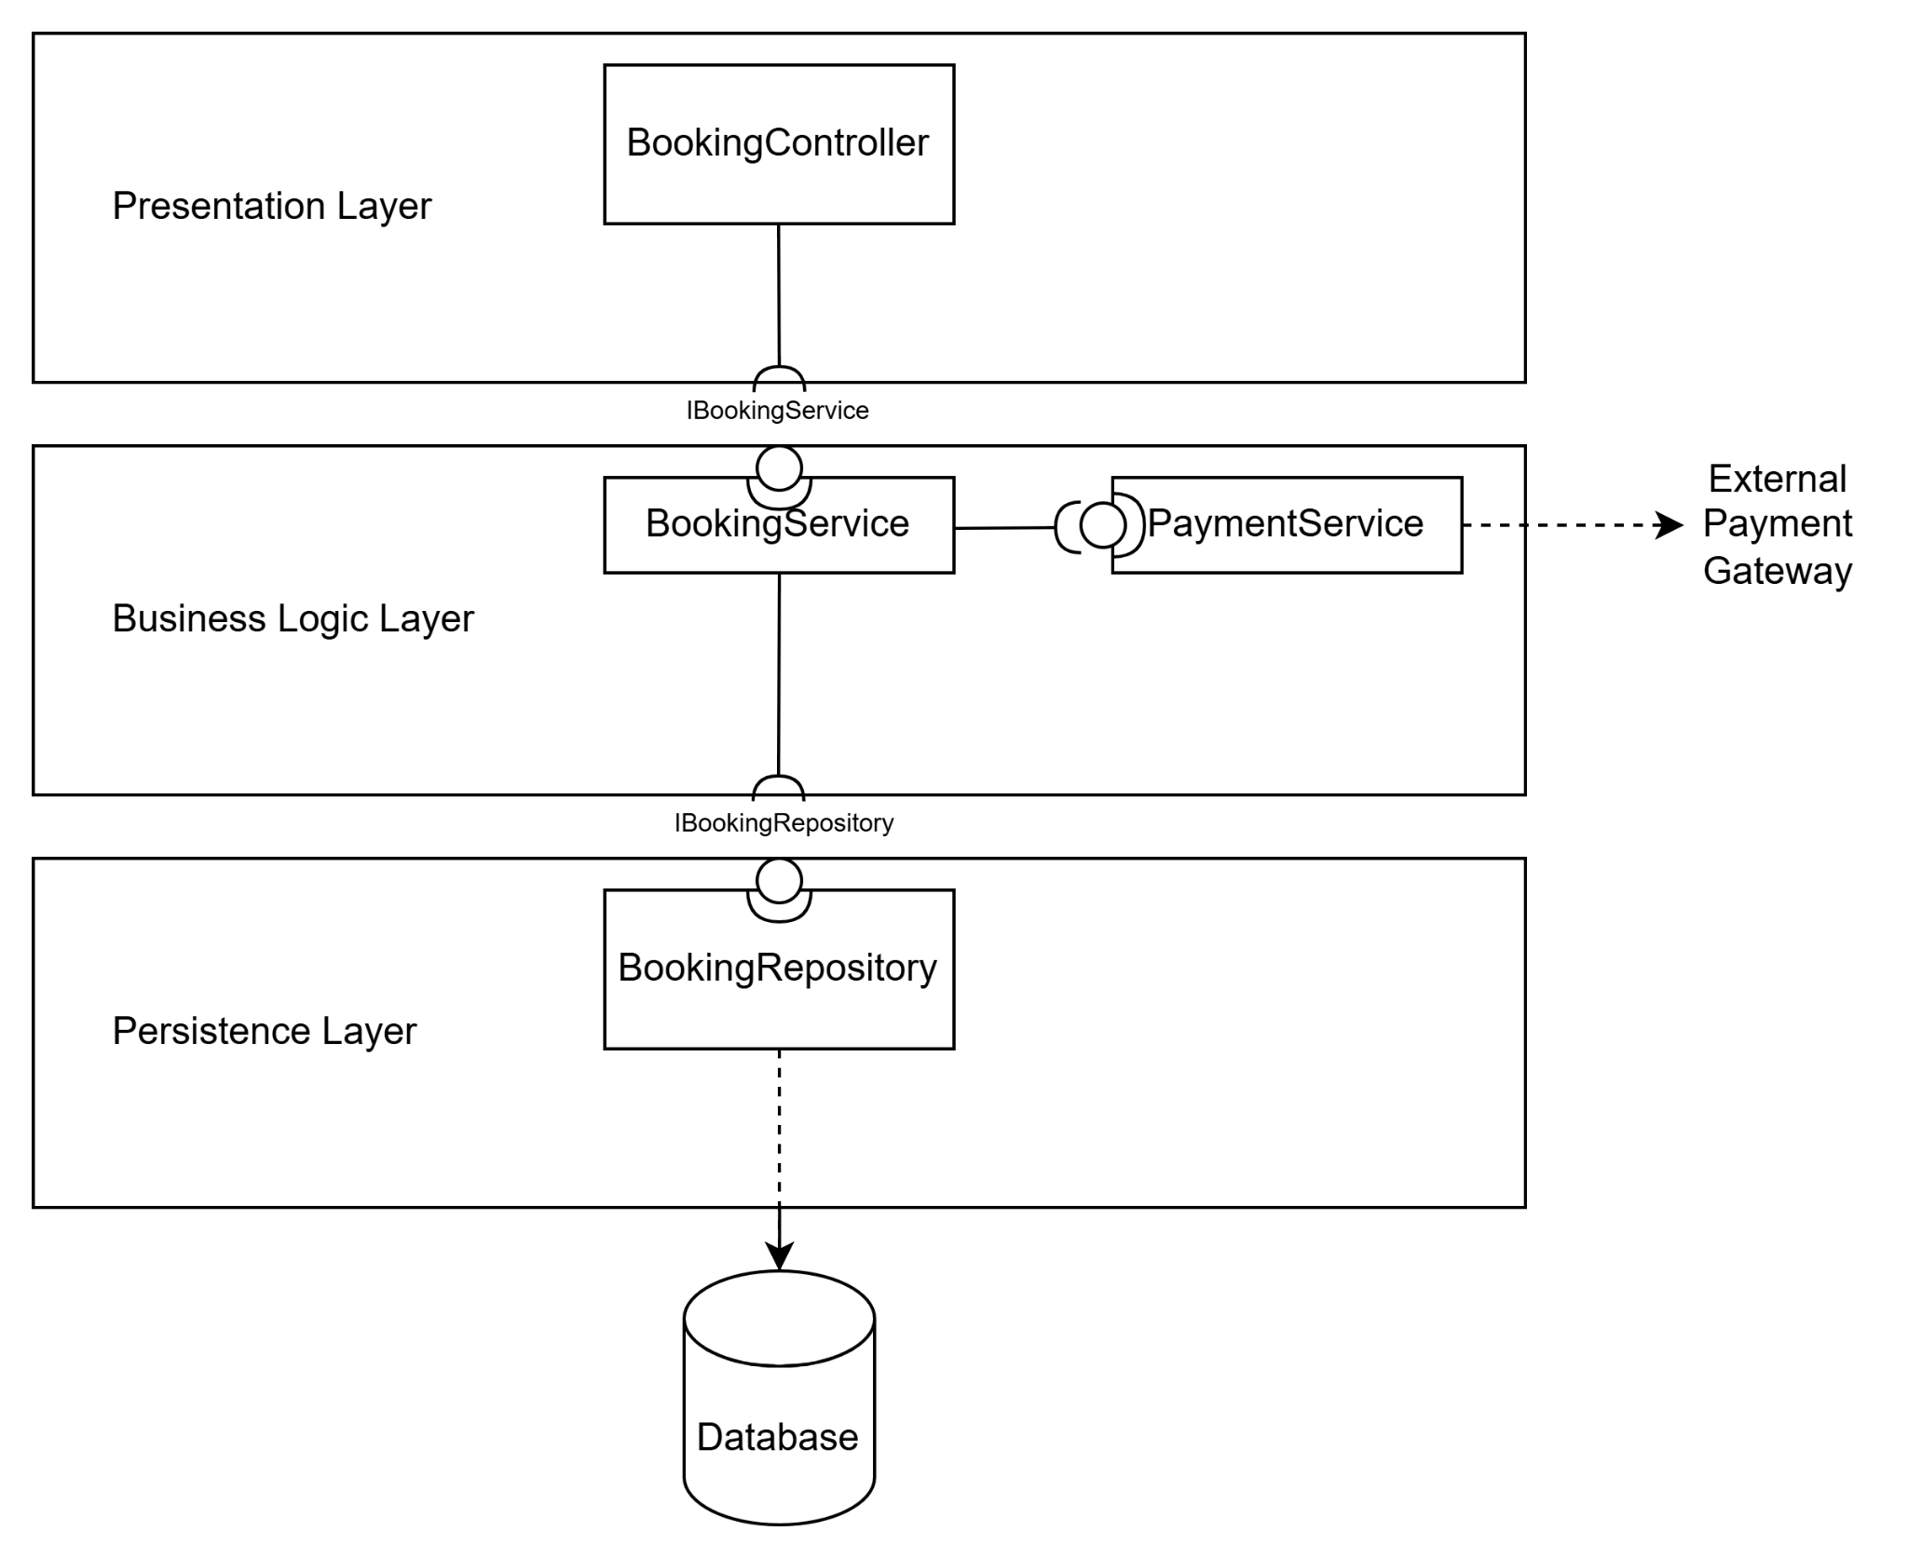
Shows: Controller → Service → Repository → Database flow with Payment Gateway integration
Complete view: All 30+ components across 4 layers with dependencies
4.5 Data Flow Analysis
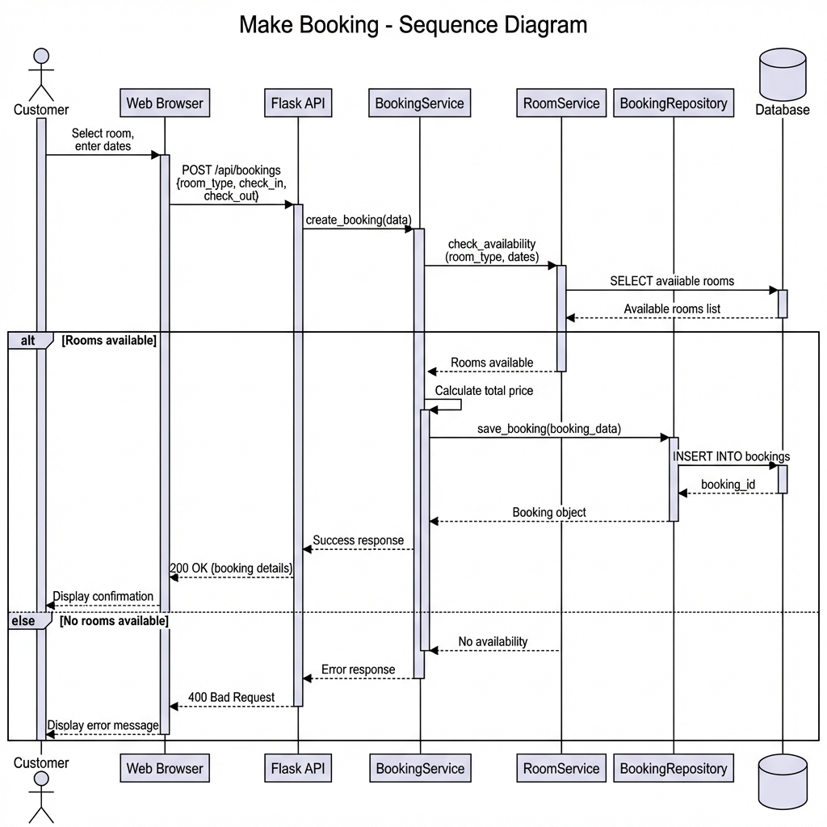
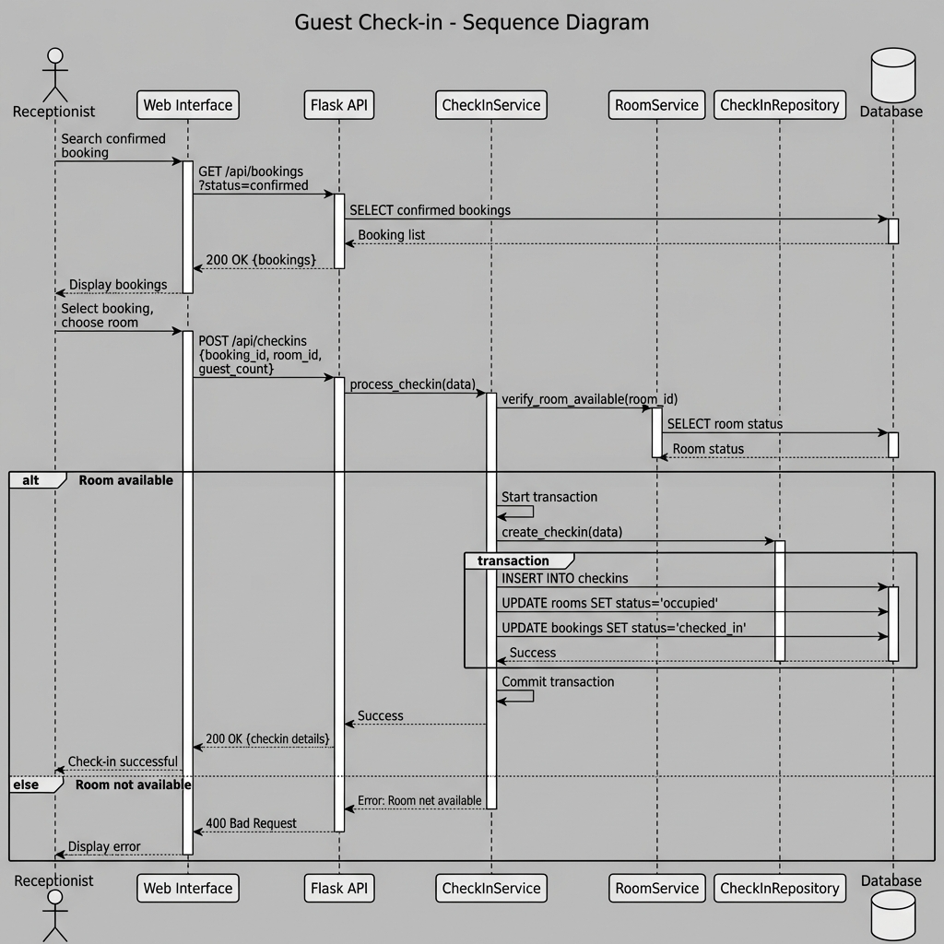
4.6 Architecture Decision Records (ADRs)
ADR ID | Decision Title | Status | Context (Why needed?) | Decision | Positive Consequences | Negative Consequences / Trade-offs
ADR-001 | Adoption of Strict 4-Layer Architecture | Accepted | Need strong modifiability (ASR-3), testability, and SQL isolation | Adopt strict 4-layer architecture (Presentation → Business → Persistence → Data) | UI changes do not affect business logic; service layer is unit-testable; SQL confined to repository | More boilerplate code; slight performance overhead
ADR-002 | Selection of Flask over Django | Accepted | Need explicit architecture and microservices readiness | Use Flask instead of Django | Clear separation of layers; flexible structure; easier microservices migration | Slower initial development; risk of inconsistent structure
ADR-003 | Adoption of Repository Pattern | Accepted | Avoid coupling domain logic with database | Use Repository pattern with raw SQL | Clean separation of concerns; DB switchability; easy mocking for tests | Verbose SQL; manual mapping required
ADR-004 | Use of JWT for Stateless Authentication | Accepted | Need scalable and stateless authentication (ASR-1, ASR-2) | Use JWT-based authentication | Stateless scaling; mobile-ready; reduced DB load | Token revocation complexity; security risks if token leaked
ADR-005 | Transition to Microservices Architecture | Proposed / Implemented (Lab 4–5) | Monolith cannot scale efficiently for uneven traffic | Decompose system by business domains | Independent scaling; fault isolation; better availability | Increased operational complexity; DevOps overhead

4.7 Architectural Design Decisions
This section documents the key architectural decisions made during the design of the Demacia Hotel Management System, including alternative options, rationale, and architectural trade-offs.

Decision 1: Adoption of a 4-Layer Architecture Instead of 3 Layers

Context
The system requires strong modifiability, testability, and security, while maintaining clear separation of concerns between business logic and data access.

Options Considered
- 3-Layer Architecture: Presentation, Business Logic, Data (Persistence logic embedded in Business layer)
- 4-Layer Architecture: Presentation, Business Logic, Persistence, Data

Decision
Adopt a 4-Layer Architecture

Rationale
- Improved Testability: Business Logic can be unit-tested independently by mocking repository interfaces.
- Technology Independence: Database technology (e.g., MySQL → PostgreSQL) can be replaced by modifying only the Persistence layer.
- Clear SQL Isolation: All SQL queries are confined to the Repository layer, reducing the risk of SQL injection and data leakage.
- Alignment with Domain-Driven Design (DDD): The Repository pattern is a recommended best practice in DDD for separating domain logic from persistence concerns.

Consequences / Trade-offs
- Slightly increased architectural complexity.
- More boilerplate code compared to a 3-layer approach.

Decision 2: Selection of Flask Over Django Framework

Context
The framework must support explicit architectural layering, flexibility, and suitability for future migration to microservices.

Options Considered
- Django: Full-featured framework with built-in ORM and admin interface.
- Flask: Lightweight micro-framework.

Decision
Use Flask as the backend framework

Rationale
- Explicit Layering: Flask allows manual separation of controllers, services, and repositories, whereas Django’s ORM encourages tight coupling between models and persistence logic.
- Educational Value: Flask exposes architectural decisions more clearly, avoiding hidden framework abstractions.
- Microservices Readiness: Flask-based services are easier to decompose into independent microservices in later labs.
- Flexibility: Avoids dependency on Django’s opinionated project structure.

Consequences / Trade-offs
- Requires manual implementation of authentication, validation, and ORM integration.
- Fewer built-in features compared to Django.

Decision 3: Use of Repository Pattern Instead of Active Record Pattern

Context
The system must maintain clean layer boundaries and high maintainability while supporting independent testing.

Options Considered
- Active Record Pattern: Domain models directly manage persistence (e.g., Django ORM).
- Repository Pattern: Persistence logic is encapsulated in dedicated repository classes.

Decision
Adopt the Repository Pattern

Rationale
- Single Responsibility Principle: Domain models represent business concepts only; repositories handle data persistence.
- Enhanced Testability: Repository interfaces can be easily mocked in unit tests.
- Database Independence: Persistence logic can be changed without modifying domain models.
- Clear Layer Separation: Persistence responsibilities are explicitly placed in the Persistence layer.

Consequences / Trade-offs
- Additional abstraction layers.
- Slight increase in implementation effort.

4.8 Traceability to Requirements
This section demonstrates how the architectural decisions support both functional and non-functional requirements, ensuring consistency between requirements, design, and implementation.
Requirement | Architectural Scope | Implementation Mapping
ASR-3: UI changes must not affect business logic | All 4 layers | Strict separation ensures the Presentation layer can be redesigned without modifying Service or Repository code.
NFR-08: Maintainability | All layers | Layer independence enables localized changes (e.g., SQL optimization in Repository without impacting Services).
FR-01: Room Search | All layers | RoomController → RoomService → RoomRepository → Database
FR-03: Booking Management | All layers | BookingController → BookingService → BookingRepository → Database
NFR-02: Secure password storage | Persistence + Data | UserRepository hashes passwords before storing them in the database.
ASR-4: Prevent double booking | Business Logic + Persistence | BookingService enforces validation rules; BookingRepository checks for conflicting reservations.

5. LAB 3: LAYERED ARCHITECTURE
5.1 Implementation Architecture
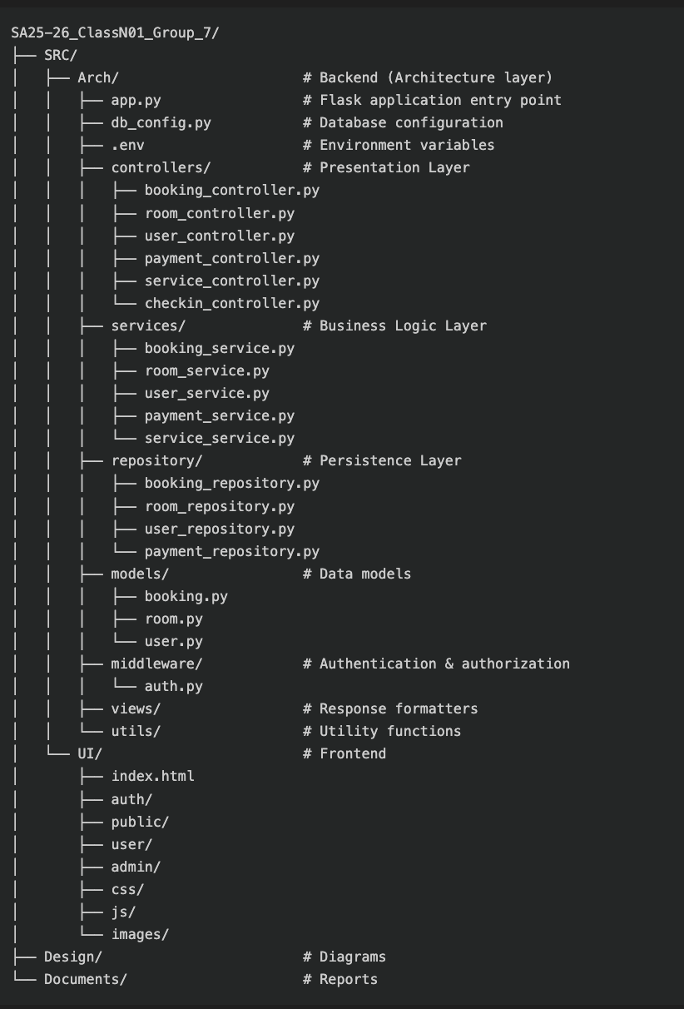
5.2 Database Design
ER Diagram
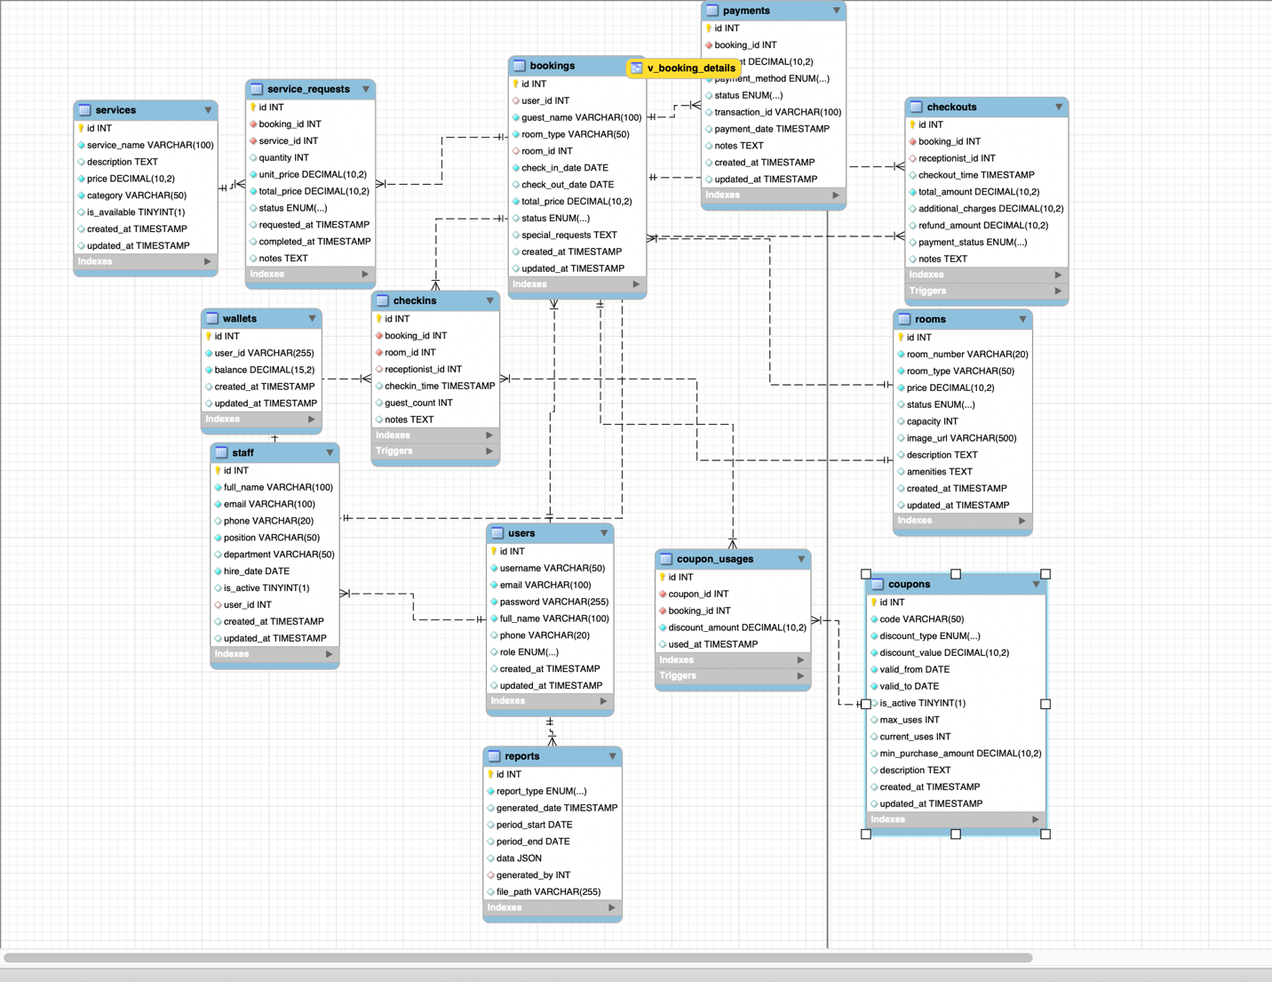5.3 API Endpoints

1. Authentication & User Management APIs
Method | Endpoint | Description | Auth Required | Role
POST | /api/users/register | Register a new user | No | -
POST | /api/users/login | User login | No | -
GET | /api/users/{user_id} | Get user details | Yes | User, Admin
PUT | /api/users/{user_id} | Update user profile | Yes | User, Admin
DELETE | /api/users/{user_id} | Delete user account | Yes | Admin

2. Room Management APIs
Method | Endpoint | Description | Auth Required | Role
GET | /api/rooms | List all rooms | No | -
GET | /api/rooms/{room_id} | Get room details | No | -
GET | /api/rooms/search | Search available rooms | No | -
POST | /api/rooms | Create new room | Yes | Admin
PUT | /api/rooms/{room_id} | Update room information | Yes | Admin
DELETE | /api/rooms/{room_id} | Delete room | Yes | Admin
POST | /api/rooms/assign | Assign room to booking | Yes | Receptionist

3. Booking Management APIs
Method | Endpoint | Description | Auth Required | Role
GET | /api/bookings | List all bookings | Yes | Receptionist, Admin
GET | /api/bookings/{id} | Get booking details | Yes | User, Receptionist, Admin
POST | /api/bookings | Create booking | Yes | User
PUT | /api/bookings/{id} | Update booking | Yes | User, Receptionist
DELETE | /api/bookings/{id} | Cancel booking | Yes | User, Receptionist
GET | /api/bookings/user/{user_id} | Get bookings of a user | Yes | User, Admin
PUT | /api/bookings/{id}/confirm | Confirm booking | Yes | Receptionist
PUT | /api/bookings/{id}/cancel | Cancel booking with reason | Yes | User, Receptionist

4. Payment APIs
Method | Endpoint | Description | Auth Required | Role
POST | /api/payments | Process payment | Yes | User, Receptionist
GET | /api/payments/{id} | Get payment details | Yes | User, Admin
GET | /api/payments/booking/{booking_id} | Get payments by booking | Yes | User, Admin

5. Hotel Service APIs
Method | Endpoint | Description | Auth Required | Role
GET | /api/services | List all services | No | -
GET | /api/services/{id} | Get service details | No | -
POST | /api/services | Create new service | Yes | Admin
PUT | /api/services/{id} | Update service | Yes | Admin
DELETE | /api/services/{id} | Delete service | Yes | Admin
POST | /api/services/request | Request hotel service | Yes | User

6. Check-in / Check-out APIs
Method | Endpoint | Description | Auth Required | Role
POST | /api/checkins | Process guest check-in | Yes | Receptionist
POST | /api/checkouts | Process guest check-out | Yes | Receptionist
GET | /api/checkouts/summary/{booking_id} | Get checkout summary | Yes | Receptionist, User

7. Staff Management & Reporting APIs (Admin Only)
Method | Endpoint | Description | Auth Required | Role
GET | /api/staff | List all staff | Yes | Admin
POST | /api/staff | Add staff member | Yes | Admin
PUT | /api/staff/{id} | Update staff information | Yes | Admin
DELETE | /api/staff/{id} | Remove staff member | Yes | Admin
GET | /api/reports/revenue | Revenue report | Yes | Admin
GET | /api/reports/occupancy | Occupancy report | Yes | Admin
GET | /api/reports/bookings | Booking statistics report | Yes | Admin

Summary Table
Category | Endpoints
Authentication & Users | 5
Rooms | 7
Bookings | 8
Payments | 3
Services | 6
Check-in / Check-out | 3
Staff & Reports | 7
Total | 52

5.4 Sequence Diagrams
Sequence Diagram 1: Complete Booking Flow

Sequence Diagram 2: Check-in Process

5.5 Testing Results

API Test Coverage Overview
Category | Total Endpoints | Tested | Passed | Failed | Pass Rate
Authentication | 5 | 5 | 5 | 0 | 100%
Rooms | 7 | 7 | 7 | 0 | 100%
Bookings | 8 | 8 | 8 | 0 | 100%
Payments | 3 | 3 | 3 | 0 | 100%
Services | 6 | 6 | 6 | 0 | 100%
Check-in / Check-out | 3 | 3 | 3 | 0 | 100%
Staff Management | 4 | 4 | 4 | 0 | 100%
Reports | 3 | 3 | 2 | 1 | 67%
Wallets | 2 | 2 | 0 | 2 | 0%
TOTAL | 52 | 52 | 48 | 4 | 92%

Failed Endpoints (Non-blocking)
Endpoint | Reason
/api/wallets/balance | Wallet feature not fully implemented
/api/wallets/topup | Wallet top-up logic pending
/api/reports/advanced | Complex analytics not implemented in current scope
These failures are non-critical and relate to features explicitly marked as future enhancements.

5.5.2 Integration Testing Scenarios
End-to-end integration tests were executed to verify that multiple components collaborate correctly across layers.

Integration Test Results
Scenario ID | Test Case | Steps | Expected Result | Status
IT-001 | Complete Booking Flow | Register → Login → Search → Book → Pay | Booking created, payment completed | PASS
IT-002 | Room Availability Check | Search rooms for occupied dates | Only available rooms returned | PASS
IT-003 | Double Booking Prevention | Book same room for overlapping dates | Second booking rejected (409 Conflict) | PASS
IT-004 | Check-in Process | Receptionist checks in guest | Status → CHECKED_IN, room OCCUPIED | PASS
IT-005 | Check-out with Services | Guest orders service → checkout | Total includes room + services | PASS
IT-006 | Booking Cancellation | Cancel confirmed booking | Status CANCELLED, room AVAILABLE, refund processed | PASS
IT-007 | RBAC Enforcement | User accesses admin endpoint | 403 Forbidden | PASS
IT-008 | Payment Failure Handling | Payment gateway error | Booking rolled back, room AVAILABLE | PASS

5.5.3 Performance Testing Results (NFR-01 Validation)
Performance tests were conducted to validate NFR-01 (Performance & Latency) under typical operational load.

Performance Metrics
Operation | Sample Size | Avg Time | 95th Percentile | Max Time | Status
Simple GET (room list) | 100 | 48 ms | 75 ms | 120 ms | PASS
Room search (filters) | 100 | 145 ms | 280 ms | 450 ms | PASS
Booking creation | 50 | 198 ms | 320 ms | 480 ms | PASS
Join query (user bookings) | 50 | 152 ms | 245 ms | 390 ms | PASS
Checkout calculation | 30 | 285 ms | 420 ms | 490 ms | PASS

6. LAB 4: MICROSERVICES DECOMPOSITION .
6.1 Service Decomposition Strategy

6.2 Service Contracts (API Design)
6.3 C4 Model Diagrams

III. C4 Model
The C4 Model Level 1 diagram illustrates the high-level boundary of the Hotel Management System and its interactions with external entities.
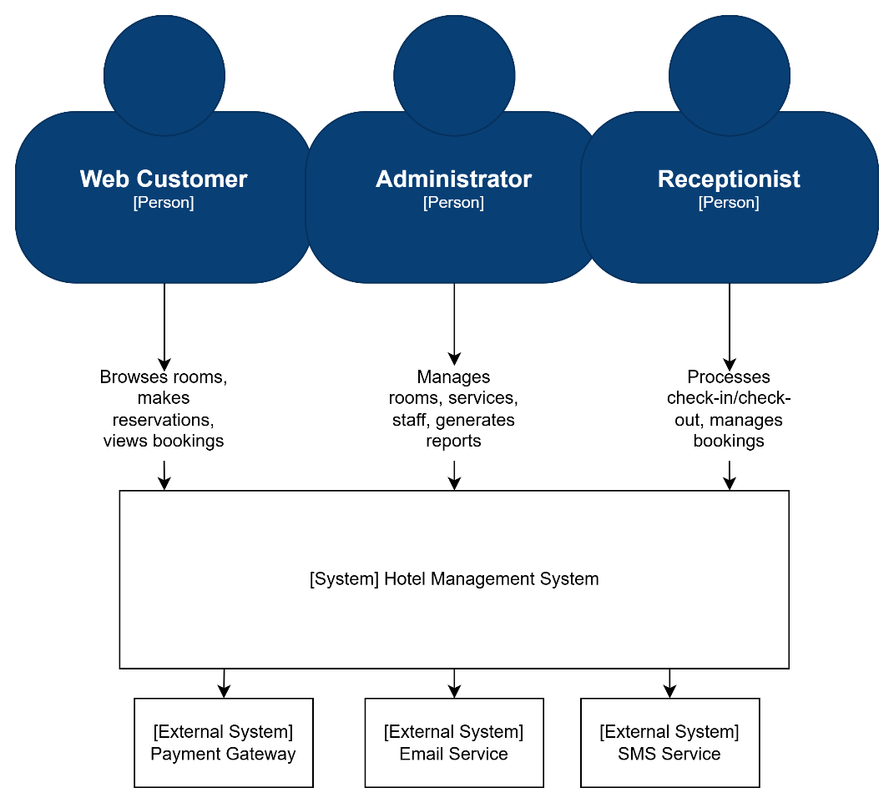

At the center of the model is the [System] Hotel Management System, which represents the entire microservices platform as a unified whole.
Surrounding this boundary are three primary human actors:
- Web Customer: Browsers the hotel website, searches for available rooms, makes reservations, and manages their bookings.
- Administrator: Manages the hotel catalog (rooms, services), staff members, and generates analytical reports.
- Receptionist: Processes guest check-in and check-out operations, manages room assignments, and handles booking modifications

The system also maintains critical interfaces with external systems:
- Payment Gateway: Processes payment transactions synchronously to ensure immediate transaction confirmation
- Email Service: Sends booking confirmations, check-in reminders, and other notifications asynchronously to avoid blocking core business operations
- SMS Service (Optional): Sends SMS notifications for booking confirmations and important updates

C4 Level 2 - Container Diagram
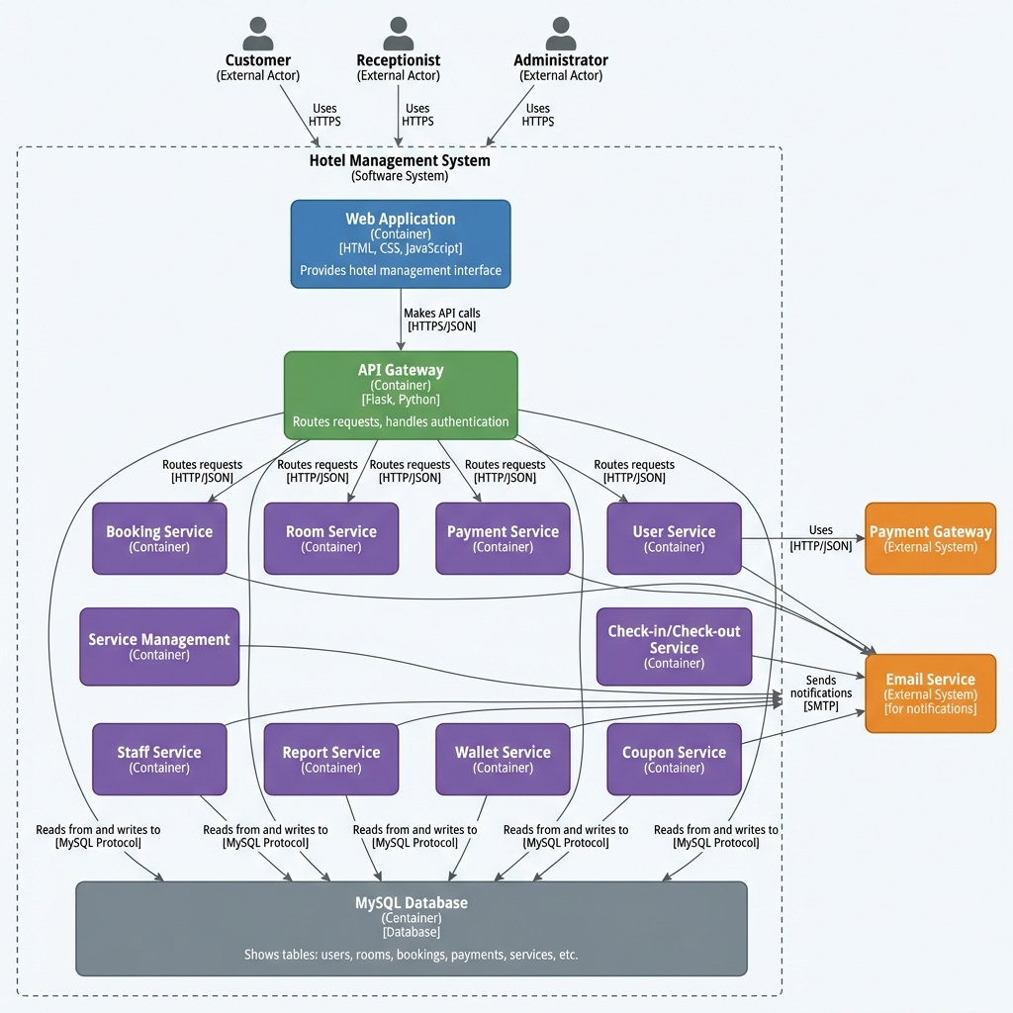

C4 Level 3 Compoment Diagrams
1. Booking Service Components
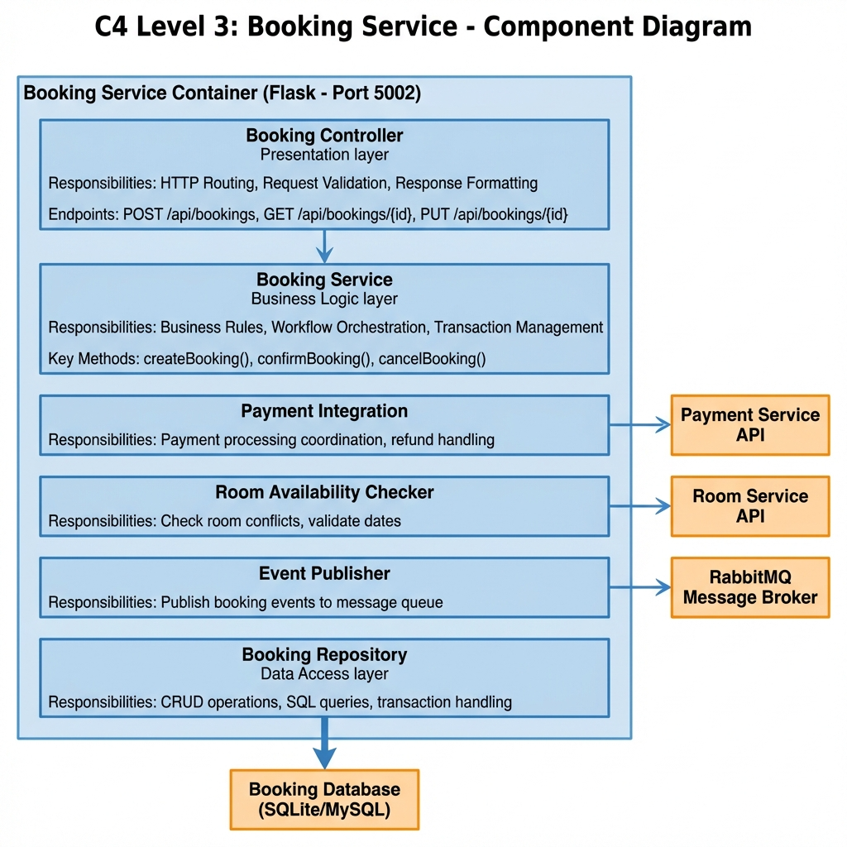

2. Room Service Components
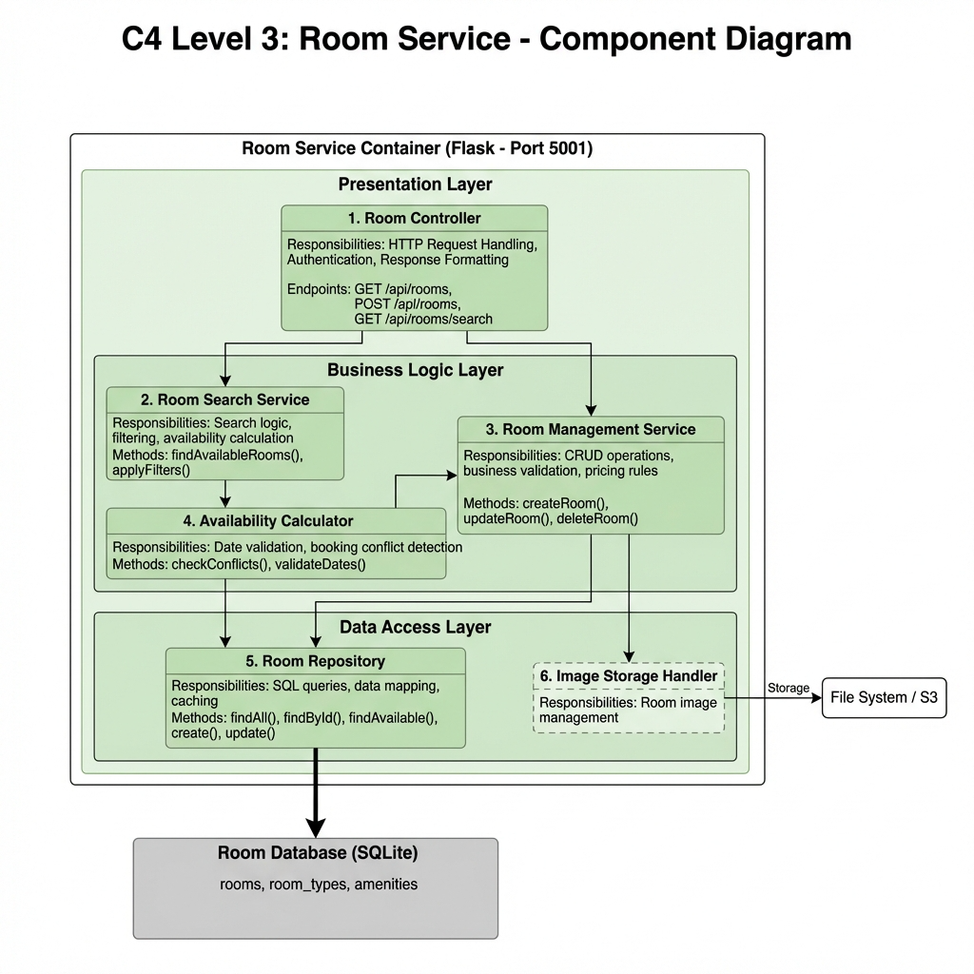

3 API Gateway Components

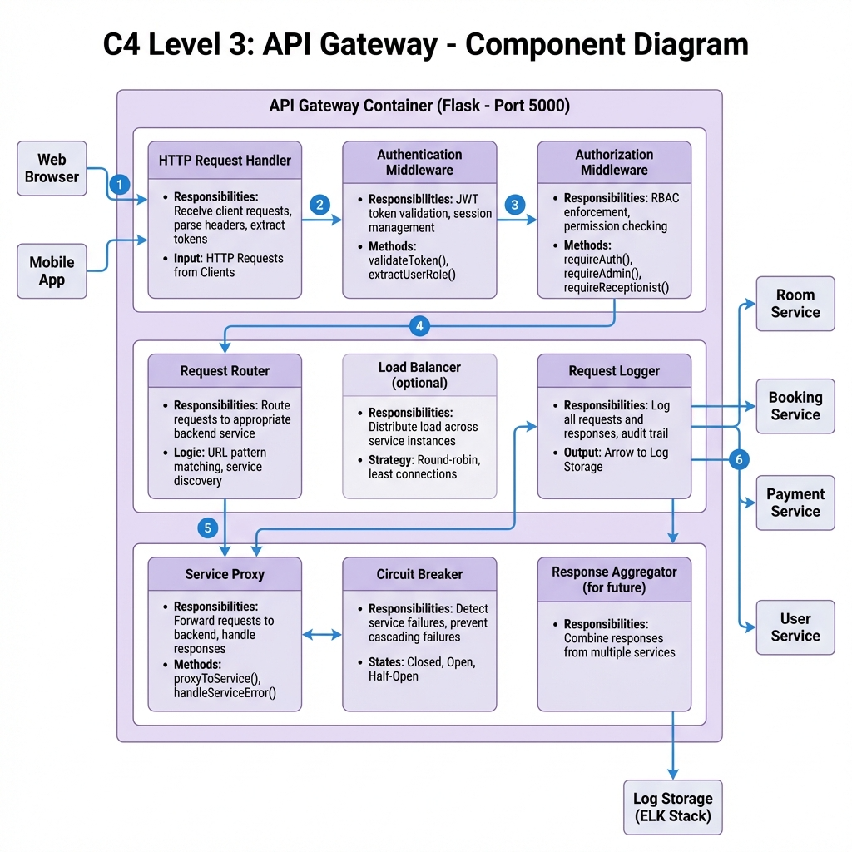
6.4 Communication Strategy
6.5 Database-per-Service Pattern

8. LAB 6: API GATEWAY PATTERN ....................... 72
8.1 Gateway Architecture

- 8.2 Implementation
- 8.3 Security & Cross-Cutting Concerns
- 8.4 Testing Results

